Big Mountain Resort has invested in a new chair lift in order to increase visitor distribution across the mountain. This additional chair lift increases operating cost by $1,540,000 this season. Management believe that we could be generating more income by increasing ticket prices but we need to find some justification in doing so. Currently ticket pricings are based on just the market average and that does not provide the business with a good sense of how important some facilities are compared to others. The business leaders want guidance on how to select a better value for their ticket price.

EDA:

Exploratory Data Analysis is an approach for summarizing and visualizing the important characteristics and statistical properties of a dataset. Our primary aim was to predict adult weekend ticket price when other features were influenced. We performed a PCA and plotted onto a graph (Fig.1), we see that in a representation of ski summaries for each state, which account for 77% of the variance, we do not each a pattern between price and state. Therefore, we decided to treat all states equally.

Fig.1

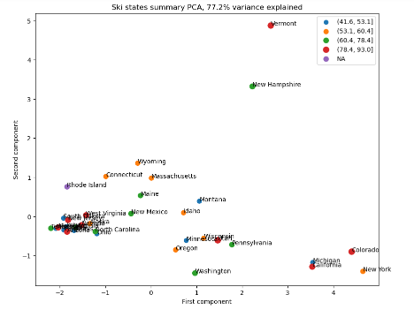

Now that we can assume that is no discernable pattern between price and state. We lay out all of our numerical features and find the relationship between each feature. Producing a Heatmap (Fig.2)

Fig.2

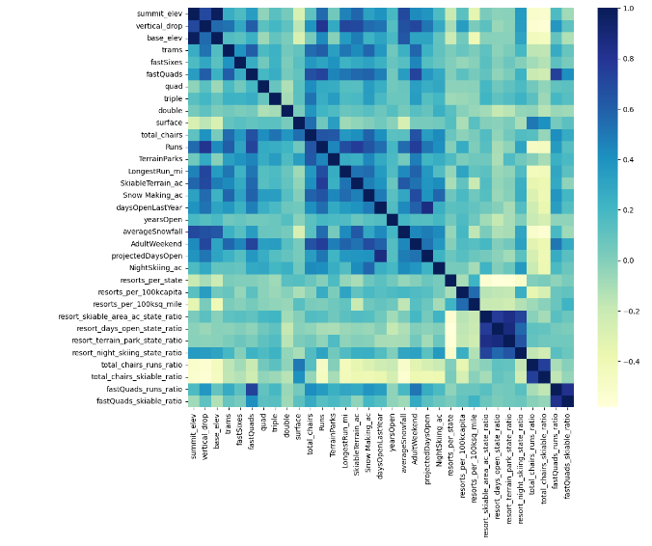

Determining that these features should be taken into consideration:

FastQuads_runs_ratio, resort_night_skiing_state_ratio, NightSkiing_ac, projectedDaysOpen, daysOpenLastYear, Snow_making_ac, Skiable terrain, longestrun_mi, Runs, Total_chairs, FastQuads, fastsixes, trams, vertical drop.

We created a pipeline utilizing Random Forest, and assessed performance using cross-validation. And plotted our features, sorted in terms of importance (Fig.3). We see that FastQuads, Runs, snow_making_ac and Vertical_Drop are our top four features that will help us determine ticket price.

Fig.3

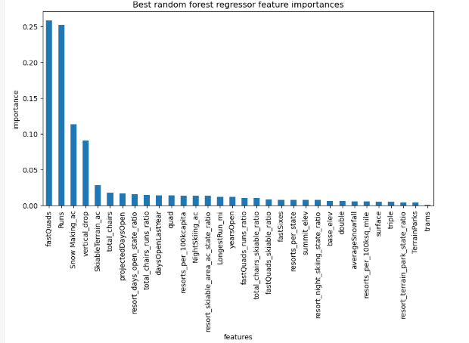

Model & Business Proposals:  
After running our model using dataset with and with Big Mountain resort. It was determined that the modelled suggested price of a ticket is $95.87, the original price is $81, an increase of about $15 more. The expected mean absolute error of $10.39, which would suggest there is room for an increase. This fairly high, the problem that we see is that our model assumes that other resorts are also accurately setting their prices to what the market supports, Big Mountain may have been very underpriced but also, other resorts may be overpriced and some underpriced as well. It could be that our model is lacking in some ways. I compared Big mountain ticket price and investigated key features between resorts, and I would say that Big mountain is ahead of the game. Big mountain is charging the most within Montana, however, it seems to be justifiable when you compare facilities to other resorts around the nation.

Modelling scenarios, we are able to use our model to tweak resort parameters to see potential scenarios for either cutting cost or increasing revenue. Business leader had provided us 4 scenarios:

1. Permanently closing down up to 10 of the least used runs. This doesn't impact any other resort statistics. (Fig.4)

Model suggests that closing one run makes no difference. Closing 2 and 3 reduces the support for ticket prices. Closing 3 also further decreases supports but no further loss in ticket price if 4 and 5 are also closed. Does not make sense to close more than 5 cause the drop ticket price becomes very significant.

Fig. 4

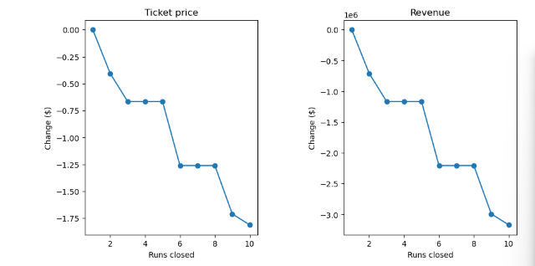

2. Increase the vertical drop by adding a run to a point 150 feet lower down but requiring the installation of an additional chair lift to bring skiers back up, without additional snow making coverage

Model suggest that in this scenario, that there is increase support for ticket price by $8.61, over the season (assuming expected visitors of 350k) returns $15,065,471 in revenue.

3. Same as number 2, but adding 2 acres of snow making cover

Model suggests that with the previous scenario in mind and an additional 2 acres of snow making, will further increase the previous model support for ticket price by $0.71, resulting in $9.90 overall ticket price and expected return of $17,322,717

4. Increase the longest run by 0.2 mile to boast 3.5 miles length, requiring an additional snow making coverage of 4 acres

Model suggest no difference.